Nick Chang

DCE LAB 1 (designing and analyzing a DCE)

Short Background:

Discrete Choice Experiments were originally an economic research tool designed to quantify the importance of specific attributes that contribute to a decision (Lancsar & Louviere, 2008). DCEs have since been repurposed into healthcare fields by using them to analyze medical decision making (Chen et. al, 2015; Hauber et. al, 2016; Lancsar & Louviere, 2008; Mulbacher & Johnson, 2016; Poder et. al, 2019; Shanahan et. al, 2019; Trapero-Bertran et. al, 2019). Many of the studies that use DCEs to inform healthcare policy and spending pit two comparable treatments for the same medical problem against each other in order to quantify the importance of each attribute of the treatment (Chen et. al, 2015; Poder et. al, 2019; Shanahan et. al, 2019; Trapero-Bertran et. al, 2019). This document was designed to familiarize readers with the terminology and process of a DCE so that anyone may be able to read my code and understand from a methodological perspective why I did what I did. First I introduce terms that are used in the design and analysis of DCE’s, I then describe the steps that are taken in a true DCE and finally I clarify what steps I will be taking and why.

TERMS:

Below I created a table of common terms that are used in the design and analysis of DCE’s.

|  |  |  |  |
| --- | --- | --- | --- |
| Ex.  figure# | Abbreviation | Term | Definition |
| DESIGN TERMS | | | |
| 1 | DCE | Discrete Choice Experiment | A type of experiment that identifies the important choice factors in a specific decision. |
| 1 |  | Attribute | A characteristic of the choice that exists in all of the choices even if it exists differently |
| 1 |  | Level | The different possibilities of how an attribute may exist within a choice(typically expressed through a numerical or qualitative value) |
| 1 |  | Treatment/Alternative | a choice represented by a combination of attributes and their levels |
| 1 |  | Choice set | single set of alternatives for a participant to choose from |
| 1 | OMED | Orthogonal Main-Effect Design | Essentially a way to describe two treatments in terms of their attributes and levels |
|  |  | multinomial DCE | DCE with 3 or more alternatives/treatments |
|  |  | binary DCE | DCE with only 2 treatments |
| 1 |  | opt out DCE | A DCE that includes an opt out option if neither treatment seem enticing |
|  |  | Forced Choice | A DCE with no opt out option, forcing participants to choose from one of the available options |
|  |  | Common Base | A DCE where every choice set has one choice that appears in all choice sets |
|  |  | Labeled | the alternatives are labeled so they can be distinguished from eachother |
|  |  | Generic | each choice set uses alternative 1 and alternative 2 |
|  | RD | Rotation design | Unlabeled DCE design slowly increases or decreases "levels" within the attributes for one option and looks at when the individual switches their choice to the other option |
|  | MaM | Mix and Match design | Modifies the rotation design by addition a randomization process (does the same thing but in a different order) |
|  | LMA | LMA Design | creates a very different format that uses rows in the OMED to correspond to alternatives and columns of attributes and levels. Doesn't appear to be used much. |
| ANALYSIS TERMS | | | |
|  | CL | Conditional Logit | a model that asks a participant would you rather A or B (and maybe C or more) |
|  | BL | Binomial Logit | a model that asks a participant would you buy this product yes or no |

EXAMPLES:

FIGURE 1

This is a single choice set in a DCE, the design is an OMED layout

The green dots indicate an attribute, while the red dots indicate the level

Therapy A and Therapy B are both examples of treatments or alternatives

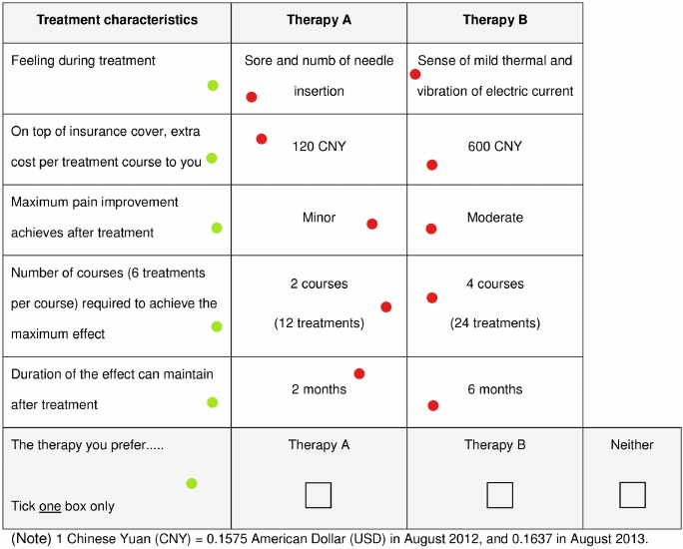

Figure 1: Example of an unlabeled DCE OMED design created by Chen et. al, 2015

STEPS FOR A DCE:

Recently I did a literature review of DCE’s specifically regarding their methodology. Below I created an outline of the steps involved in designing and analyzing DCE’s

1. Create the design
   1. define the situation in which respondents will need to make this decision
   2. specify the options a respondent may have
   3. define the options in terms of their attributes and levels
      1. focus groups
      2. literature review
      3. individual interviews
      4. expert interviews
      5. mixed stakeholder boards
   4. decide to include or leave out the opt out option
   5. decide on the number of alternatives per choice set
2. Conduct the survey with your DCE design
   1. writing the questions (choice sets)
   2. creating questionnaire (design OMED)
   3. Determine sampling frame of targeted population
   4. select survey modality
   5. decide on sampling method
   6. choose sample size
   7. sample respondents
3. Prepare dataset and analyze data
   1. prepare and clean data
   2. perform analysis

STEPS I WILL DO:

While there are a number of steps to performing a real DCE, my goal was to leave this course with the ability to design a DCE using given attributes and levels, and analyze given data from a DCE to elicit both the collective preference ranking and individual preference rankings. This is my goal primarily because of time constraints and an inability to conduct data collection for both the qualitative research needed in the design phase and the DCE questionnaire for the quantitative phase. That being said here are my proposed steps.

1. Create the design
   1. Find a hypothetical DCE situation and decide on the appropriate DCE design
   2. Either find previous research that explicitly states attributes and levels or make them up based on assumptions, understandings, and light research.
   3. Create the choices based on attributes and levels (OMED design)
   4. Create a questionnaire based on the OMED
2. Analyzing the data
   1. Make a design matrix for analysis
   2. Either make up or find a dataset to be analyzed
   3. Perform the proper analysis based on the DCE design and data metrics

Much of my design is explained above, for the moment I will try explaining my analysis in script, if it seems clunky I will add a section about the analysis here.

Yup, it seems clunky I will have to add a section with the right visuals and equations. I am starting on this now, but it will probably come slowly over the next couple of days.

ANALYSIS:

It seems the analysis can be broken down into two major parts. First, we estimate a model based on our data, then we can evaluate the model using goodness of fit and likelihood ratios.

ESTIMATION:

DCE Analysis is based squarely in Random Utility Theory. RUT states that for every choice set *S* with two or more options, individual *n* will choose the option (*i or j)* that has the most utility *U* for that individual:

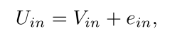

Such that *Uin* is the utility gained by individual *n* by choosing option *i.* RUT also states that the utility of this decision (*Uin)* can be broken down into two discrete parts. These two parts are known as the systematic component (*Vin)* and the random component*(ein)*. The systematic component is by far the simpler of the two, essentially it is determined by attribute variables of option *i* while the random component is unobservable and therefore random to the analyst.

Including another option (*j)* in a choice set where *i* provides the most utility, we can yield these two equations:

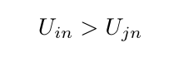

Which is equivalent to:



Now things get a little tricky as we delve into probabilities to circumvent the problem of the random component being unobservable. Instead of calculating which choice generates higher utility values, we must calculate the probability that option *i* is greater than option *j*:

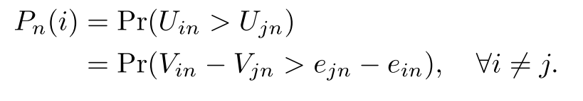

The above equation is the general premise, but we can be more specific in more specific choice experiments. Typically, choice experiments are broken down into binomial or multinomial, both of which have their own equation based on the number of options involved. For multinomial or CL models, the following equation is derived:

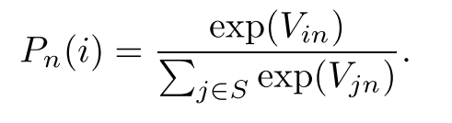

For binomial or BL models, this equation is derived:

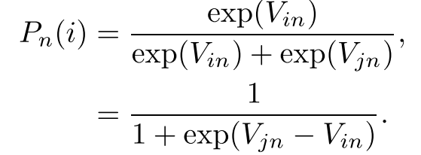

The systematic component in these equations is assumed to be a linear additive function of the independent variables *Xikn,* and can be calculated through this equation:

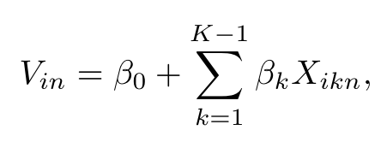

Where β0 is a constant, βk is the coefficient of variable *Xikn*, and K is the number of coefficients including the constant. The random component on the other hand is estimated using a “maximum likelihood technique”. For a sample of N independent observations, the log likelihood function is written as:

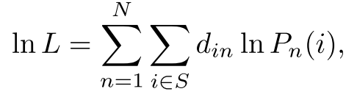

Where *din* is an indicator variable equal to 1 if *n* selects alternative *i* and 0 if not.

EVALUATION:

Learning Resources:

The first resource I found was a website created by Hideo Aizaki and designed to teach DCE design and analysis in R:

<http://lab.agr.hokudai.ac.jp/nmvr/02-dce.html>

Next I found a paper on the same topic: <https://pdfs.semanticscholar.org/b0fb/05e51e02d4eda914888ae0590dd65b45ff9a.pdf>

Another resource I found is a paper describing a new package in R that is designed to help with DCE design and analysis: <https://www.sciencedirect.com/science/article/abs/pii/S1755534519300703?via%3Dihub>

Lastly I used a textbook written by Hideo Aizaki that covers stated preference methodology of which DCE is a part of: <https://www.taylorfrancis.com/books/9780429065699>

References

Azaki, H. (2019, August 29). Non-Market Valuation with R. Retrieved March 29, 2020, from http://lab.agr.hokudai.ac.jp/nmvr/02-dce.html

Aizaki, Hideo & Nishimura, Kazushi. (2008). Design and Analysis of Choice Experiments Using R: A Brief Introduction. Agricultural Information Research. 17. 10.3173/air.17.86.

Chen, L.-C., Cheng, L.-J., Zhang, Y., He, X., & Knaggs, R. D. (2015). Acupuncture or Low Frequency Infrared Treatment for Low Back Pain in Chinese Patients: A Discrete Choice Experiment. *PLOS ONE,* 10(5), e0126912. doi:10.1371/journal.pone.0126912

Hauber, A. B., González, J. M., Groothuis-Oudshoorn, C. G., Prior, T., Marshall, D. A., Cunningham, C., . . . Bridges, J. F. (2016). Statistical Methods for the Analysis of Discrete Choice Experiments: A Report of the ISPOR Conjoint Analysis Good Research Practices Task Force. *Value in Health,* 19(4), 300-315. doi:10.1016/j.jval.2016.04.004

Hess, S., & Palma, D. (2019). Apollo: A flexible, powerful and customisable freeware package for choice model estimation and application. *Journal of Choice Modelling*, 32, 100170. doi:10.1016/j.jocm.2019.100170

Lancsar, E., & Louviere, J. (2008). Conducting Discrete Choice Experiments to Inform Healthcare Decision Making. *PharmacoEconomics,* *26*(8), 661-677. doi:10.2165/00019053-200826080-00004

Mühlbacher, A., & Johnson, F. R. (2016). Choice Experiments to Quantify Preferences for Health and Healthcare: State of the Practice. *Applied Health Economics and Health Policy,* *14*(3), 253-266. doi:10.1007/s40258-016-0232-7

Poder, T. G., Beffarat, M., Benkhalti, M., Ladouceur, G., & Dagenais, P. (2019). A discrete choice experiment on preferences of patients with low back pain about non-surgical treatments: Identification, refinement and selection of attributes and levels*. Patient Preference and Adherence*, Volume 13, 933-940. doi:10.2147/ppa.s201401

Shanahan, M., Larance, B., Nielsen, S., Cohen, M., Schaffer, M., & Campbell, G. (2019). A protocol for a discrete choice experiment: Understanding patient medicine preferences for managing chronic non-cancer pain. *BMJ Open,* *9*(8). doi:10.1136/bmjopen-2018-027153

Trapero-Bertran, M., Rodríguez-Martín, B., & López-Bastida, J. (2019). What attributes should be included in a discrete choice experiment related to health technologies? A systematic literature review. *Plos One,* *14*(7). doi:10.1371/journal.pone.0219905